Paralympic Heritage: Stories from…….
Call for Disabled Artists

Artist Brief for
22 workshops across Buckinghamshire

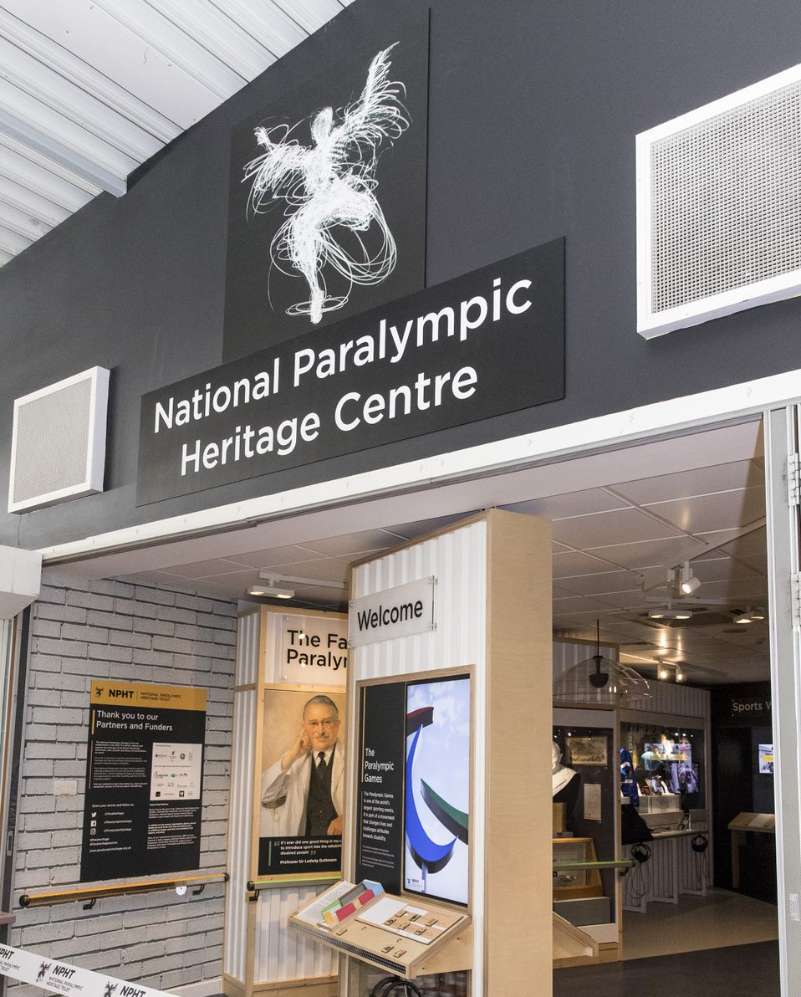

Who we are:

“We exist to enlighten and inspire future generations by celebrating, cherishing and bringing the Paralympic heritage and its stories of human endeavour to life”

The National Paralympic Heritage Trust was established in 2015 as a response to the huge success of London 2012 when it became apparent that this British history, which culminated in a significant celebration of disability sport, needed to be protected for posterity. This is a history that spans more than 70 years. The team now safeguards and shares a growing collection of photographs, letters, sports equipment, documents, medals and Paralympic clothing which tell the story of the Games and its origins in Buckinghamshire.

Underlying all our work is the aim to challenge negative perceptions of disability through the exploration and sharing of this inspiring and unique history.

As part of our outreach and learning programme, the Trust has secured a grant from the HS2 Community Fund to engage communities and local schools to share the heritage, uncover and record the stories behind the evolution of the Paralympic Games.

As part of this we would like to work with disabled artists, from a variety of practice backgrounds ranging from graphic designers to performance artists, to create and deliver workshops inspired by our heritage collection. Workshops will take place between June 2021 and November 2022 and we will deliver 22 separate workshops. Artists should indicate in their application, whether they would be available to deliver more than one project.

Artist Brief:

Participating Artists will be paid to:

- share their art and story as an artist with local community groups and schools.
- select an item, theme or story from the NPHT displays in the Heritage Centre or the National Spinal Injuries Unit at Stoke Mandeville Hospital or our website, sharing the reasons for their choice
- use the item, theme or story to inspire and deliver a workshop in collaboration with the partner schools and groups

Artists will ideally work in person but we shall accommodate your needs, including virtual engagement.

Completed work will be shared via online exhibitions and small-scale exhibitions within our Heritage Centre and National Spinal Injury Centre displays. We will promote the project and output through our social media channels and share links to your practice.

Time Commitment:
Two days per community or school

Fees:
We shall pay £300 a day plus materials, expenses and access costs.

How to Respond to this Brief:

The National Paralympic Heritage Trust is inviting responses to this brief and is open to disabled artists from all areas of practice.

Please send:

- a letter, (no more than 2 sides of A4) expressing your interest, briefly outlining your practice, how it relates to this proposal, workshop experience in schools and community groups and explaining what interests you about this opportunity.
- a CV
- up to 8 jpg images (ideally saved as a single PDF) of recent work or no more than a 3 minute film/audio depending on your practice to admin@paralympicheritage.org.uk by 5pm on Monday 31st May 2021.

Further information:
For further information or an informal conversation please email Fiona Darling-Glinski – fiona.darlingglinski@paralympicheritage.org.uk

Interviewing:
Interviews will be by Zoom or a preferred choice of virtual meeting on Friday 11th June 2021.

Site visits:
Prior to submitting an application you can pay a virtual visit to our Heritage Centre using the following link https://www.paralympicheritage.org.uk/Event/heritage-centre#Virtual_tour

ACCESS:
If you have access requirements, please do not hesitate to contact us with your request for support.

Background:

The Paralympic Movement owes its existence to Sir Ludwig Guttmann, a neurologist (and German Jewish refugee) at Stoke Mandeville Hospital, who believed passionately that access to sport played a vital role in the rehabilitation of those suffering injury or disease to the spine. The National Paralympic Heritage Centre at Stoke Mandeville Stadium celebrates and explores this unique history.

The displays at the Heritage Centre and the National Spinal Unit, showcase the determination, sportsmanship and vision that gave the world the Paralympic Games including:
- the life and work of Professor Sir Ludwig Guttmann.
- key milestones in the journey from the 1948 Stoke Mandeville Games to the 2016 Paralympic Games.
- the development of wheelchair sports.
- Paralympic ceremonies.
- the history of the National Spinal Injuries Centre
- technological advances and medical innovation.
Other themes that might act as inspiration and are part of the stories we are currently uncovering are:
- The Finmere Show - A fundraising event which took place for over 30 years.
- the First Wheelchair Marathon - witnessed and supported across many Buckinghamshire villages.
- the changing diet and lifestyles of Paralympians.
- the evolving branding and promotional material associated with the Games

It is an inspiring and moving story with the early part of the collection being of international significance. It tells the history of a remarkable movement through the many individuals who have been part of the Games, including stories of the support teams behind the athletes. Part of our important work is to connect this unique local history with the communities who supported the Games from the very beginning and we are inviting disabled artists from all areas of practice to work with us in this endeavour.

Our museum opened to the public in March 2019 and 37,000 people visited the museum in its first year and there have been over 50,000 virtual visits. The museum is placed within the Stoke Mandeville Sports Stadium, a general sports centre with specialist facilities for wheelchair users.

Our Collection:

Included in the Collections are medals, torches, sports equipment and sportswear. We now have a complete collection from Rome 1960 to Rio 2018 including wheelchairs, trophies, flags, medical records, a bed hand cycling machine (designed by Dr Guttmann and at the London Science Museum), score boards, posters, programmes, gifts, personal and business letters and a very rich collection of photographs and films. More recently we have received the British Paralympic Collection that includes 69 costumes and the costume bible from London 2012 as well as models of the set design from the Paralympic opening ceremony, an event that had a profound impact on national consciousness.

Forthcoming events which resonate with our heritage brief are the upcoming Tokyo 2020 Summer Games and Beijing 2022 Winter Games. Whilst covering current Games is not our area of activity as our focus is the heritage of the Paralympic Movement, we do have material which relates to the Tokyo 1964 Summer Games, the Nagano Winter Games in Japan in 1998 and the Beijing Summer Games in 2008.

To support your work you will have access to the following:

- the permanent displays at the Heritage Centre and the National Spinal Unit
- a comprehensive website which is key to our delivery, including a growing oral history collection which is continually updated
- a visual timeline
- a virtual tour of the Heritage Centre and National Spinal Unit (planned)
- virtual access to our handling collection via our vlogs
- regional hub exhibitions and virtual tours telling local Paralympic stories
- support from knowledgeable and enthusiastic staff and volunteers
- on site accommodation is available in the Olympic Lodge at Stoke Mandeville Stadium
- our accessible museum, website and branding.

Please visit our website for more information: https://www.paralympicheritage.org.uk

